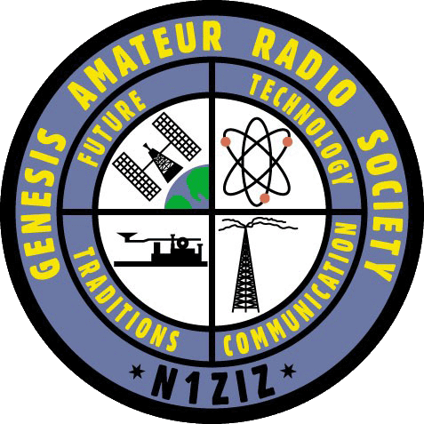
GARS Membership Application
Name: _________________________________________________ Call sign: ___________________
Address: __________________________________________________________________________
City/Town: ________________________________ State:___________ Zip Code: _______________
Phone: Day: ______________________________ Evening: ____________________________
Email Address: _____________________________________________________________________
License Class: Tech General Extra Are you an ARRL Member: Yes No
Club Sponsor: ___________________________________________ Call Sign: ________________________
Talent Bank Information:
Please list any skills or talents that you think may be of interest to the club: _____________________________
__________________________________________________________________________________________
Explain why you would like to join the GARS Club: __________________________________________________
___________________________________________________________________________________________
How will you commit to support the clubs activities and comities if approved as a member? Please be specific: ____________________________________________________________________________________________
____________________________________________________________________________________________
____________________________________________________________________________________________

I ________________________________, Call sign ____________, hereby apply for membership in the Genesis Amateur Radio Society (GARS). In applying for membership and signing this form, I hereby agree to abide by the By-Laws of the Club and the laws and rules of the Federal Communications Commission (FCC). I further understand that after completion of the probationary period of this application I will be entitled to all rights and privileges of membership as provided in the By-Laws.
Signature: ____________________________________________________________ Date: __________________
Approved by: _________________________________________________________ Date: __________________
Please forward Application to: Genesis Amateur Radio Society at N1ZIZradio@Gmail.com. When the application is received, you will be contacted to attend a meeting. At that time you should present a completed application along with your first year’s dues. The club will vote on your membership status and you will be notified accordingly

